**Use of Keywords**

* Static
* Final
* This

**Java static keyword**

The **static keyword** in [Java](https://www.javatpoint.com/java-tutorial) is used for memory management mainly. We can apply static keyword with [variables](https://www.javatpoint.com/java-variables), methods, blocks and [nested classes](https://www.javatpoint.com/java-inner-class). The static keyword belongs to the class than an instance of the class.

The static can be:

1. Variable (also known as a class variable)
2. Method (also known as a class method)
3. Block
4. Nested class

**Java static variable**

If you declare any variable as static, it is known as a static variable.

* The static variable can be used to refer to the common property of all objects (which is not unique for each object), for example, the company name of employees, college name of students, etc.
* The static variable gets memory only once in the class area at the time of class loading.

### Advantages of static variable

It makes your program **memory efficient** (i.e., it saves memory).

## Java static method

If you apply static keyword with any method, it is known as static method.

* A static method belongs to the class rather than the object of a class.
* A static method can be invoked without the need for creating an instance of a class.
* A static method can access static data member and can change the value of it.

Restrictions of static method

1. The static method cannot use non static data member or call non-static method directly.
2. this and super cannot be used in static context.

## 3) Java static block

## Is used to initialize the static data member.

## It is executed before the main method at the time of class loading.

* We can execute a program without main() method, one of the ways was the static block, but it was possible till JDK 1.6. Since JDK 1.7, it is not possible to execute a Java class without the [main method](https://www.javatpoint.com/java-main-method).

# 4) this keyword in Java

There can be a lot of usage of **Java this keyword**. In Java, this is a **reference variable** that refers to the current object.

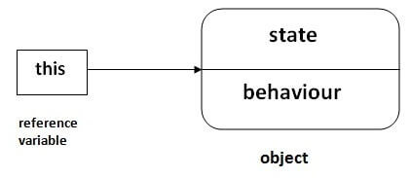

## Usage of Java this keyword

Here is given the 6 usage of java this keyword.

1. [this can be used to refer current class instance variable.](https://www.javatpoint.com/this1)
2. [this can be used to invoke current class method (implicitly)](https://www.javatpoint.com/this2)
3. [this() can be used to invoke current class constructor.](https://www.javatpoint.com/this3)
4. [this can be passed as an argument in the method call.](https://www.javatpoint.com/this4)
5. [this can be passed as argument in the constructor call.](https://www.javatpoint.com/this5)
6. [this can be used to return the current class instance from the method.](https://www.javatpoint.com/this6)

**Suggestion:** If you are beginner to java, lookup only three usages of this keyword.